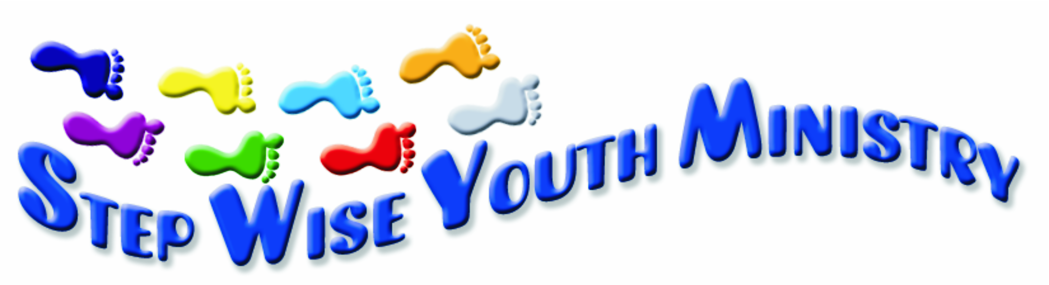
SWYM CORRESPONDENCE COURSE: PRISON MINISTRY 2013
Since the start of my involvement with SWYM three years ago, the year 2013 has been a year of many blessings.
At the moment the course consists of 15 colourful books with different topics such as The Bible, Creation, Jesus Christ, Following Jesus, Growing and walking with Jesus, The fruit of the Spirit, Qualities of a Christian, The Lord’s Prayer, Lessons from the life of Daniel/Ruth/Joseph/James, Why the cross, What to do to be saved. Each book is sent out with a list of Bible references as well as a quiz sheet that can be sent back to SWYM to qualify for a certificate.
We started this year with 43 active correspondents and “by word of mouth” 102 new students started working through the course since January 2013. Over 150 students receive books on a regular basis.
Although it seems to be primarily a prison ministry (course material is sent to at least 6 different prisons throughout South Africa), during this year we saw a steady growth in the interest of rural community groups as well.
The course brings knowledge to young and old – from age 23 years to men in their late fifties…
We are currently busy translating the course into Afrikaans, one of the main languages in South Africa.
Anita Dekker

Testimonials:
“… I saw the course at one of my brothers and I got interested in joining it as it inspired me a lot and I want to grow in my Christianity…”
“ I am currently serving a term of five years and am doing your correspondence course … I would appreciate it if you could post this course to my boys age 16 and 8 as this course is really inspiring and I want them also to benefit…”
“ this is my last year in prison and myself will never ever think again of committing fraud in my life … In Oct I will be back with my wife and children and would like to continue with your Bible studies”

